**# Installation guide**

Install Docker and add user to docker group

```

sudo yum install docker jq

sudo usermod -a -G docker ec2-user

```

Start docker

```

sudo /etc/init.d/docker start

````

Now you need to log off and on again.

You ensure docker is working by running and if you don't see any errors, docker is running.

```

docker ps

````

Install docker-compose to execute multiple docker container at the same time via the curl command.

```

sudo curl -L https://github.com/docker/compose/releases/download/1.21.0/docker-compose-$(uname -s)-$(uname -m) -o /usr/bin/docker-compose

Giving execution rights to the scripts

sudo chmod +x /usr/bin/docker-compose

```

Copy docker-compose.yml and browsers.json files to amazon machine

Nano docker-compose.yml

Copy the docker-compose.yml from windows.

Ctrl+O

Enter

Ctrl+X

Nano browsers.json

Copy the browsers.json from windows.

Ctrl+O

Enter

Ctrl+X

Then download browsers and video recording docker

```

cat browsers.json | jq -r '..|.image?|strings' | xargs -I{} docker pull {}

docker images | grep -q selenoid/video-recorder || docker pull selenoid/video-recorder

```

Now everything is installed and ready

## Selenoid usage

To start selenoid run following command. If you run that command without -d argument you can see the logs.

```

docker-compose up -d

```

To shutdown selenoid

```

docker-compose down

```

To kill and restart the ggr grid

docker kill -s HUP ggr

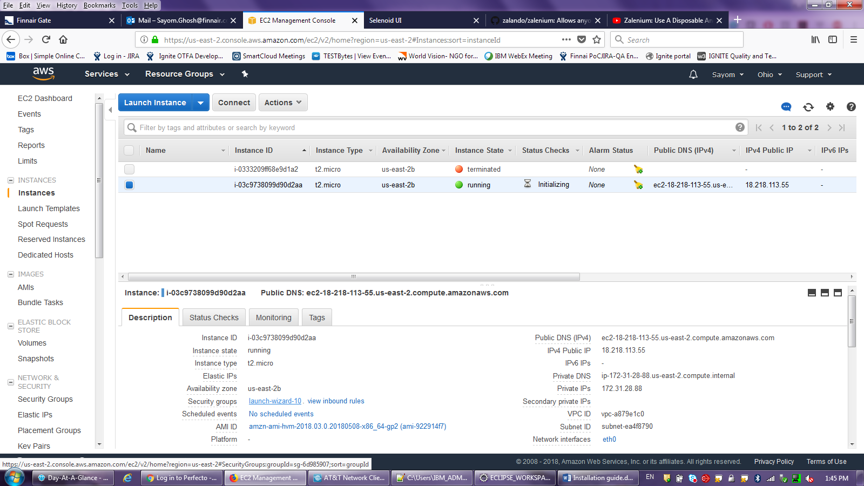

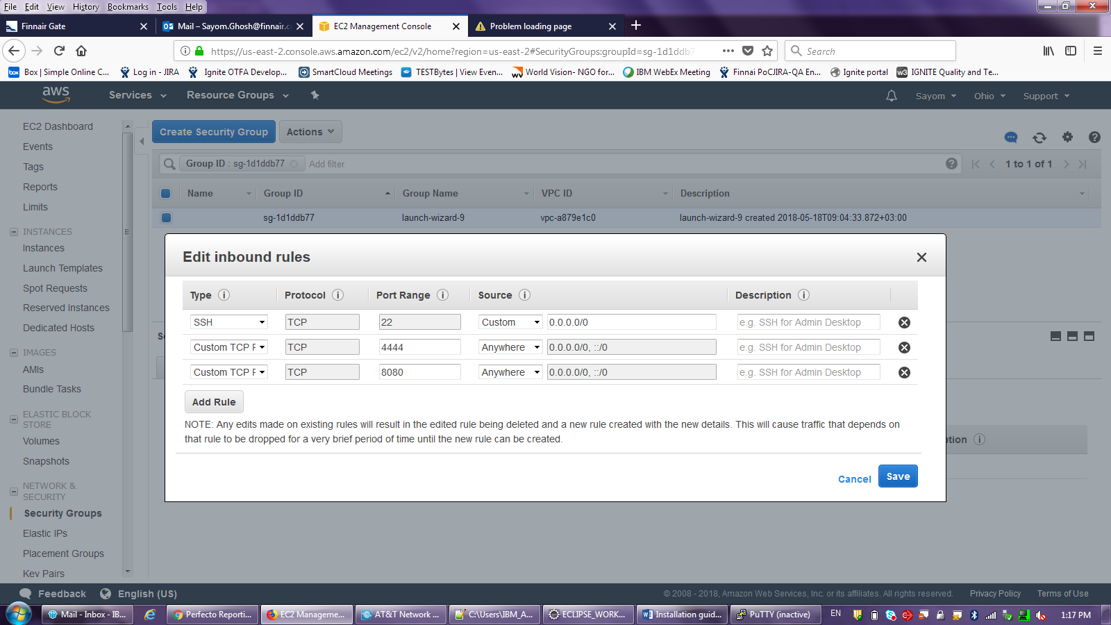

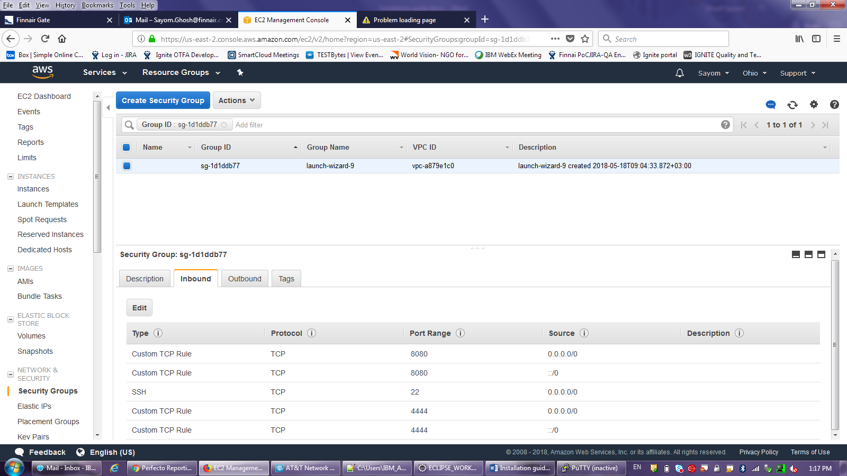

Putty guide:

ec2-18-218-113-55.us-east-2.compute.amazonaws.com

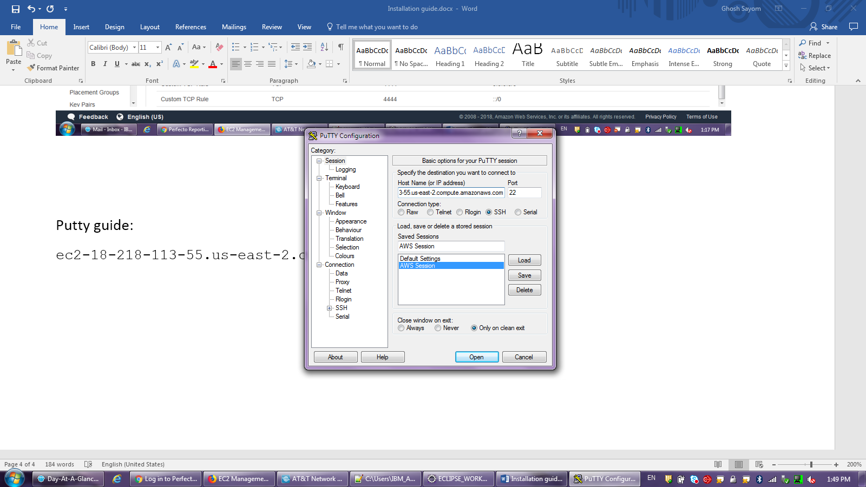

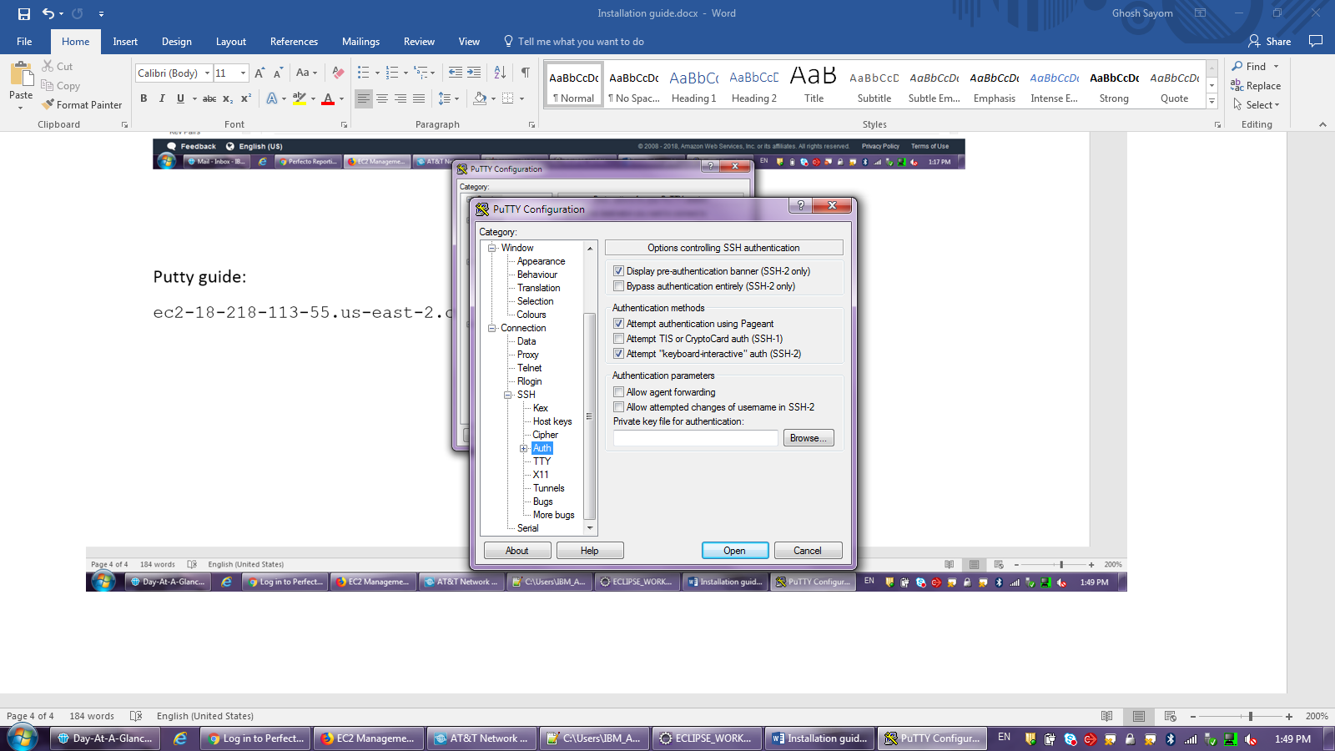

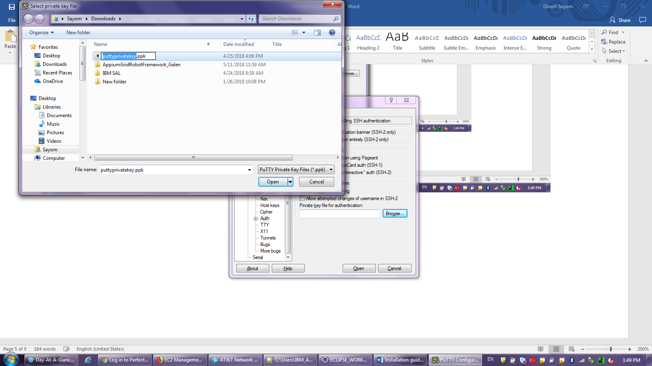

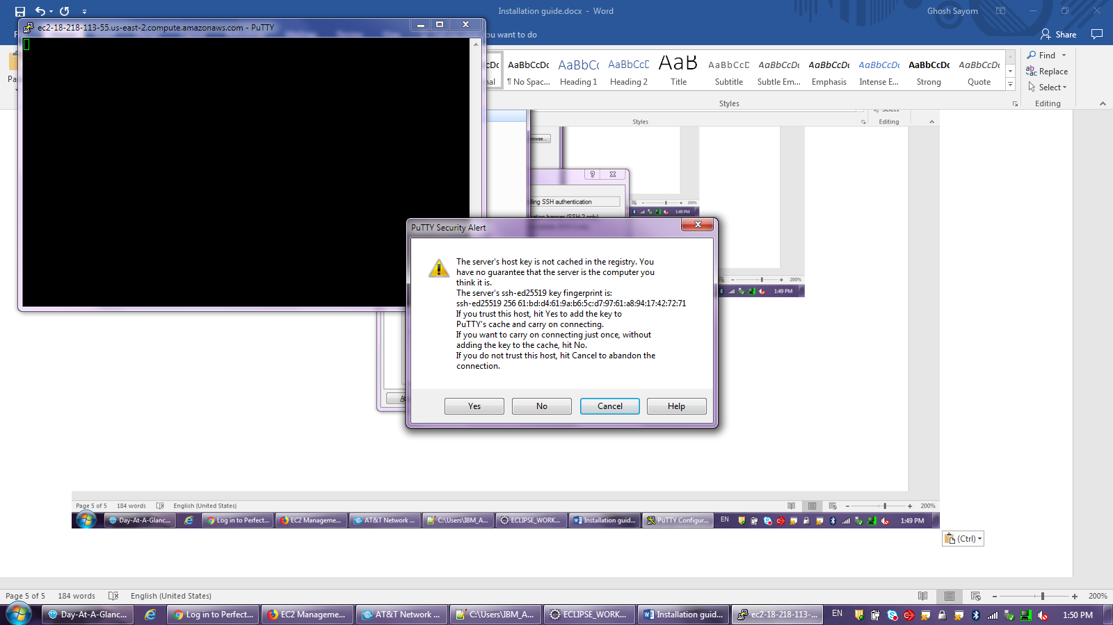

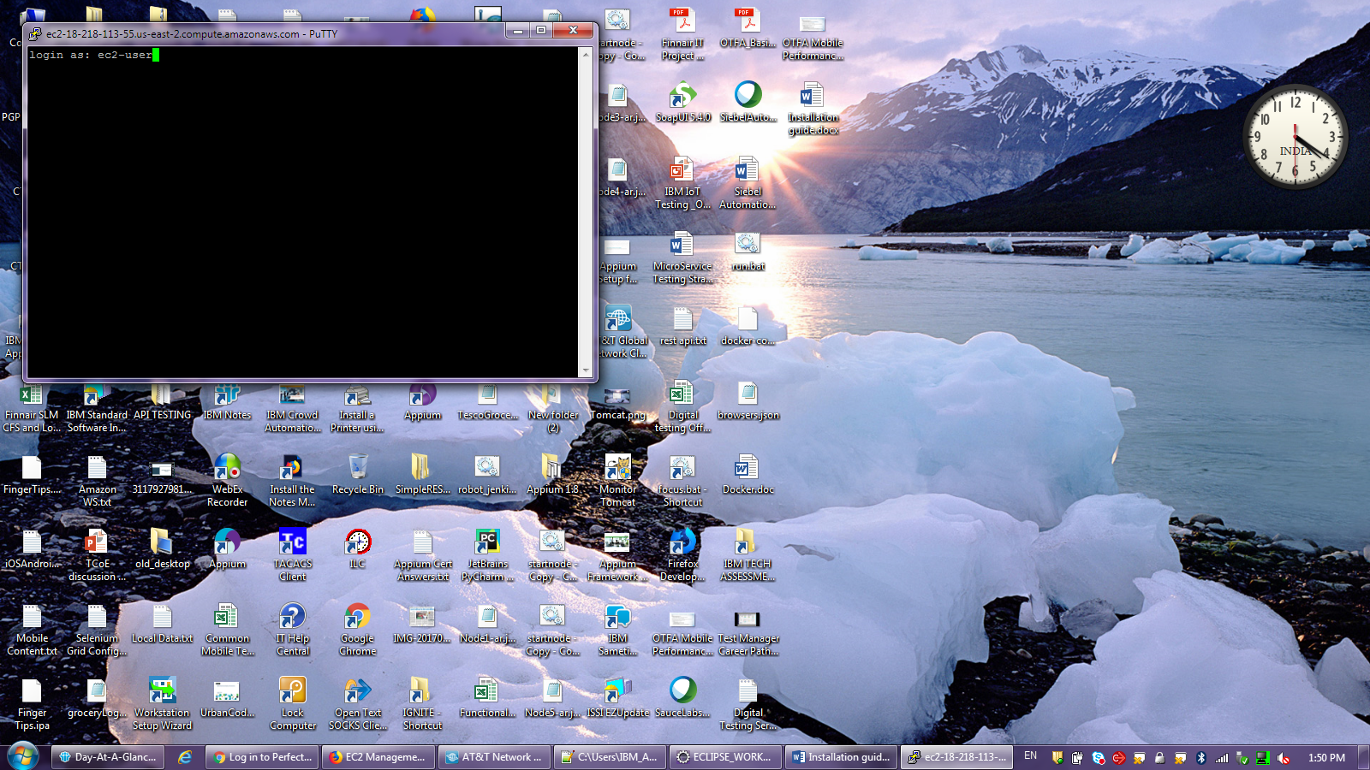

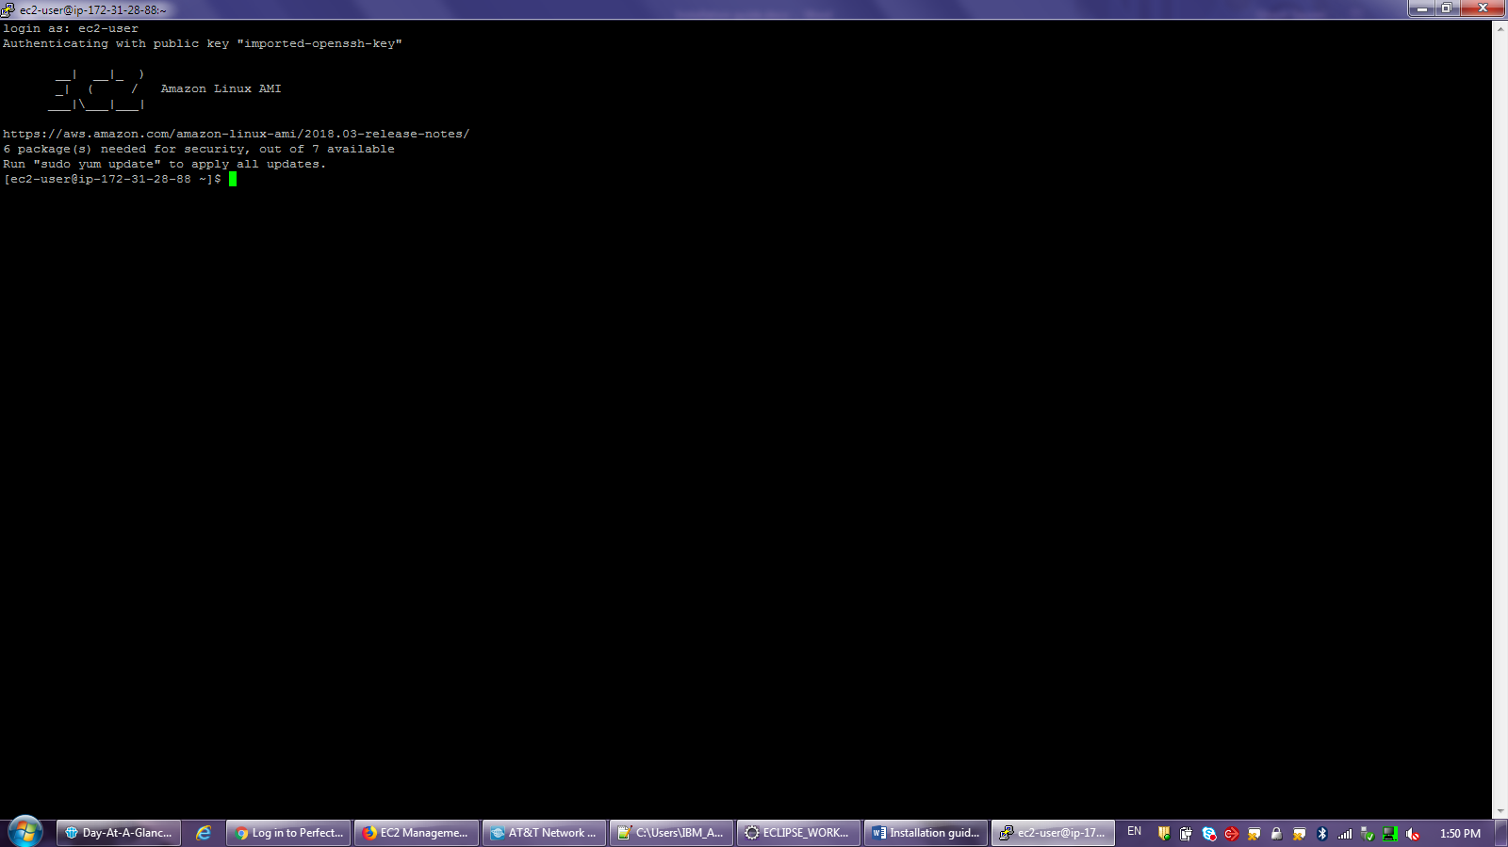

Dockercompose.yml:

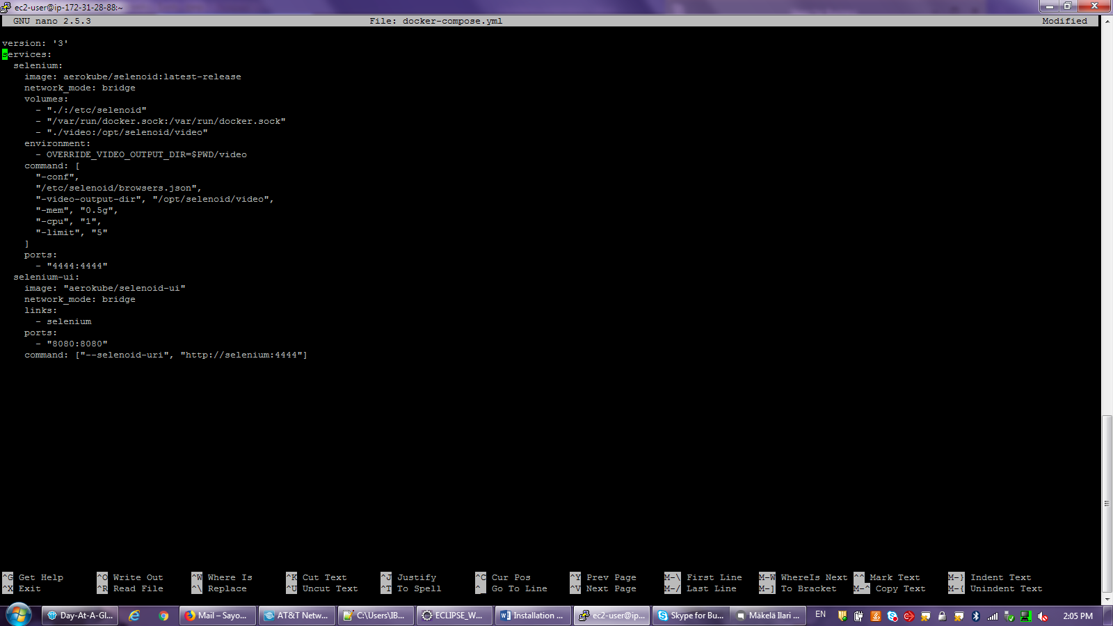

GGR Router:

1. To Start the GGR Router

sudo docker run -d --name ggr -v /etc/grid-router/:/etc/grid-router:ro --net host aerokube/ggr:latest-release

2. Configure test.yml

a. Command to go to the folder containing test.xml: cd /etc/grid-router/quota/

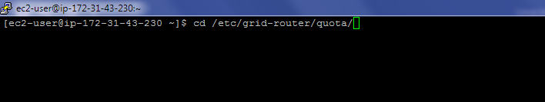

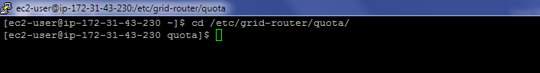

b.sudo nano test.xml and update the current ipaddress of the Selenoid Linux AMI Node1 and Node2.

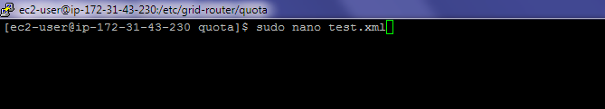

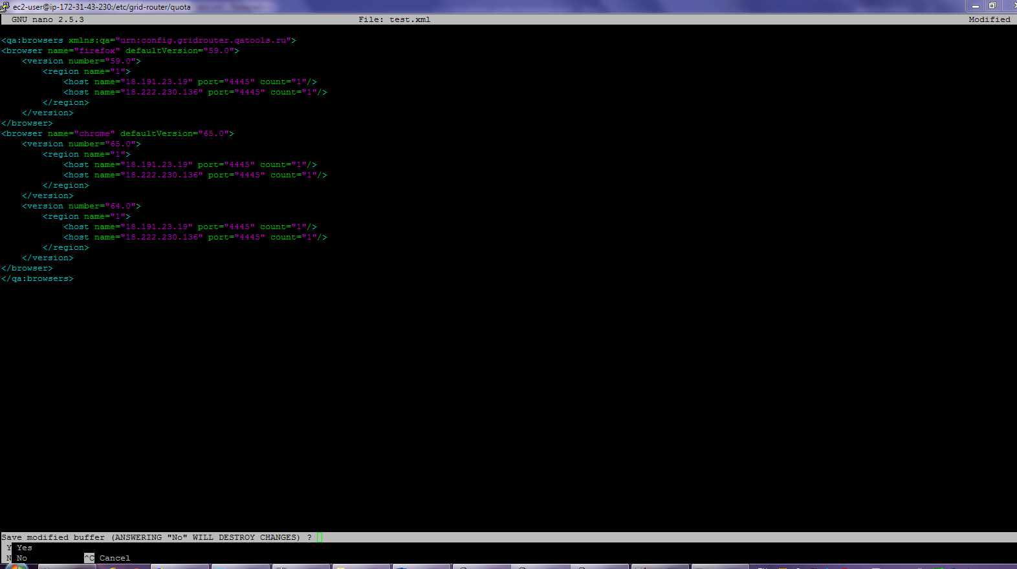

3.

a. To remove docker: docker rm ggr



b. To restart the ggr grid to take the changes being done in test.xml ips

To kill and restart the ggr grid

docker kill -s HUP ggr

4. To check docker running

docker ps -a

